OSS SDK for C++ 使用说明

baocai zhang

[www.giser.net](http://www.giser.net)

## 1 简介

Aliyun OSS C++ SDK使用c++实现了Aliyun OSS提供的功能，主要包括Bucket的创建、删除、浏览。Object的创建、删除浏览以及多点上传等功能，关于OSS提供的服务请参考OSS API说明文档。

## 2 主要内容

Aliyun OSS C++ SDK主要包括源代码（BSD协议开源）、说明文档、示例工程、帮助文档等。

该SDK开发环境为vs2012，提供了vs2012的工程文件，目前只支持windows平台，暂不支持跨平台使用。

该SDK提供头文件和动态库和lib文件用于开发。

在线帮助文档：

<http://osscppsdk.sinaapp.com/html/index.html>

## 3 第三方库

本SDK使用到的第三方类库包括以下部分：

Libcurl

Xmlparser

## 4 使用步骤

4.1 新建vs2012 工程，将vc include目录设为SDK目录下的include目录，Library目录设为SDK目录下的bin目录。

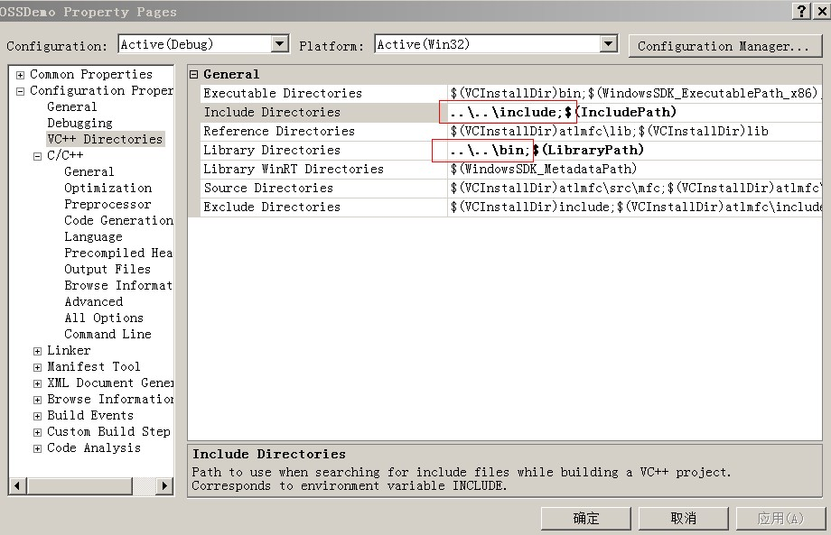

4.2 工程Output目录设为SDK目录下的bin目录。

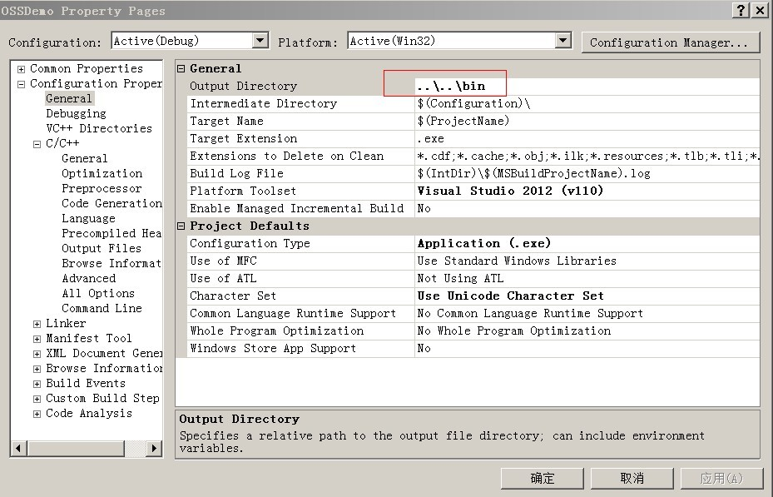

4.3 在Linker属性下Input中添加libcurl.lib和libOSS.lib

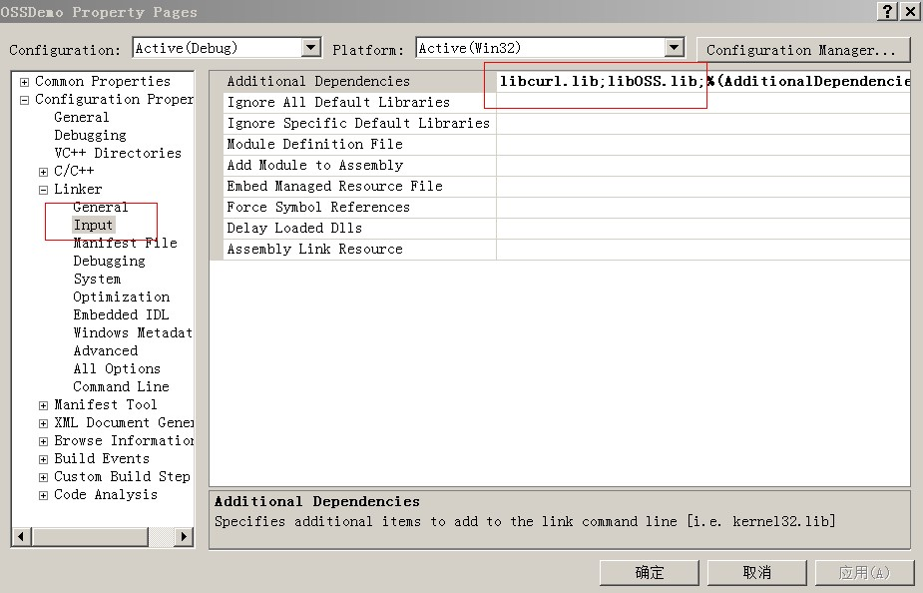

4.4 在代码中包含头文件OSSClient.h

#include "OSSClient.h"

4.5 定义OSSClient对象，并使用accessID和accessKey初始化。

OSS::OSSClient *_ptClient = new OSSClient(aID,akey,config);

4.6 使用OSSClient对OSS对象操作，OSS对象提供了四类对象的操作函数，包括Bucket，Object，MultiPart和ObjectGroup。OSSClient 还分别提供了同步和异步的方式进行调用。

4.6.1 同步方式调用

直接使用OSSClient对象调用即可。

_ptClient->ListBuckets(buckets);

4.6.2 异步方式调用

异步方式是web请求的主流请求方式，当请求返回的时候响应相关消息。

1）使用异步方式首先要实现代理类，该代理类必须继承OSS::OSSClientCallback 这个抽象基类，并实现抽象基类中定义的回调方法。

class OSSClientTest: OSS::OSSClientCallback

{

public:

OSSClientTest(void);

~OSSClientTest(void);

public:

virtual void OnCreateBucketComplete(OSSClient *client,Bucket &bucket);

virtual void OnCreateBucketFailed(OSSClient *client,OSS_RESULTCODE code);

virtual void OnDeleteBucketComplete(OSSClient *client,string &bucketName);

virtual void OnDeleteBucketFailed(OSSClient *client,OSS_RESULTCODE code);

virtual void OnListBucketsComplete(OSSClient *client,Buckets &buckets);

virtual void OnListBucketsFailed(OSSClient *client,OSS_RESULTCODE code);

virtual void OnSetBucketACLComplete(OSSClient *client);

virtual void OnSetBucketACLFailed(OSSClient *client,OSS_RESULTCODE code);

virtual void OnGetBucketACLComplete(OSSClient *client,CannedAccessControlList &aclList);

virtual void OnGetBucketACLFailed(OSSClient *client,OSS_RESULTCODE code);

virtual void OnIsBucketExistComplete(OSSClient *client,bool &isExist);

virtual void OnIsBucketExistFailed(OSSClient *client,OSS_RESULTCODE code);

virtual void OnListObjectsComplete(OSSClient *client,ObjectListing &objectListing);

virtual void OnListObjectsFailed(OSSClient *client,OSS_RESULTCODE code);

//Object Op

virtual void OnPutObjectComplete(OSSClient *client,PutObjectResult &result);

virtual void OnPutObjectFailed(OSSClient *client,OSS_RESULTCODE code);

virtual void OnFetchObjectComplete(OSSClient *client,OSSObject &object);

virtual void OnFetchObjectFailed(OSSClient *client,OSS_RESULTCODE code);

virtual void OnFetchObjectToFileComplete(OSSClient *client,string &fileName);

virtual void OnFetchObjectToFileFailed(OSSClient *client,OSS_RESULTCODE code);

virtual void OnGetObjectMetadataComplete(OSSClient *client,ObjectMetadata &objectMetadata);

virtual void OnGetObjectMetadataFailed(OSSClient *client,OSS_RESULTCODE code);

virtual void OnCopyObjectComplete(OSSClient *client,CopyObjectResult &result);

virtual void OnCopyObjectFailed(OSSClient *client,OSS_RESULTCODE code);

virtual void OnDeleteObjectComplete(OSSClient *client);

virtual void OnDeleteObjectFailed(OSSClient *client,OSS_RESULTCODE code);

virtual void OnDeleteMultipleObjectsComplete(OSSClient *client,DeleteObjectsResult &result);

virtual void OnDeleteMultipleObjectsFailed(OSSClient *client,OSS_RESULTCODE code);

virtual void OnPostObjectGroupComplete(OSSClient *client,PostObjectGroupResult &result);

virtual void OnPostObjectGroupFailed(OSSClient *client,OSS_RESULTCODE code);

virtual void OnGetObjectGroupIndexComplete(OSSClient *client,FetchObjectGroupIndexResult &result);

virtual void OnGetObjectGroupIndexFailed(OSSClient *client,OSS_RESULTCODE code);

//multipart Op

virtual void OnUploadPartComplete(OSSClient *client,UploadPartResult &result);

virtual void OnUploadPartFailed(OSSClient *client,OSS_RESULTCODE code);

virtual void OnListPartsComplete(OSSClient *client,PartListing &result);

virtual void OnListPartsFailed(OSSClient *client,OSS_RESULTCODE code);

virtual void OnListMultipartUploadsComplete(OSSClient *client,MultipartUploadListing &result);

virtual void OnListMultipartUploadsFailed(OSSClient *client,OSS_RESULTCODE code);

virtual void OnInitiateMultipartUploadComplete(OSSClient *client,InitiateMultipartUploadResult &result);

virtual void OnInitiateMultipartUploadFailed(OSSClient *client,OSS_RESULTCODE code);

virtual void OnCompleteMultipartUploadComplete(OSSClient *client,CompleteMultipartUploadResult &result);

virtual void OnCompleteMultipartUploadFailed(OSSClient *client,OSS_RESULTCODE code);

virtual void OnAbortMultipartUploadComplete(OSSClient *client,string &puloadId);

virtual void OnAbortMultipartUploadFailed(OSSClient *client,OSS_RESULTCODE code);

virtual void OnNetworkFailed(OSSClient *client,OSS_RESULTCODE code);

};

2） 定义回调代理类

OSSClientTest *ptOSSClientTest = new OSSClientTest();

3）将代理类的指针赋给OSSClient 的delegate对象

_ptClient->delegate =(OSSClientCallback *)ptOSSClientTest;

4） 调用以_Async结尾的相关方法对OSS对象操作

_ptClient->ListBuckets_Async();